Automatic transmission 1


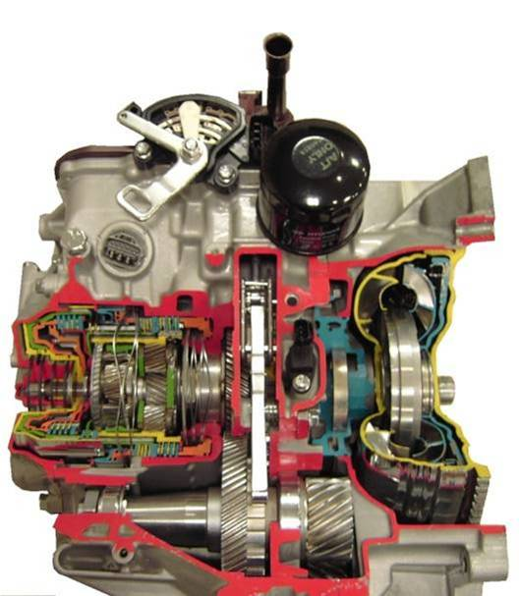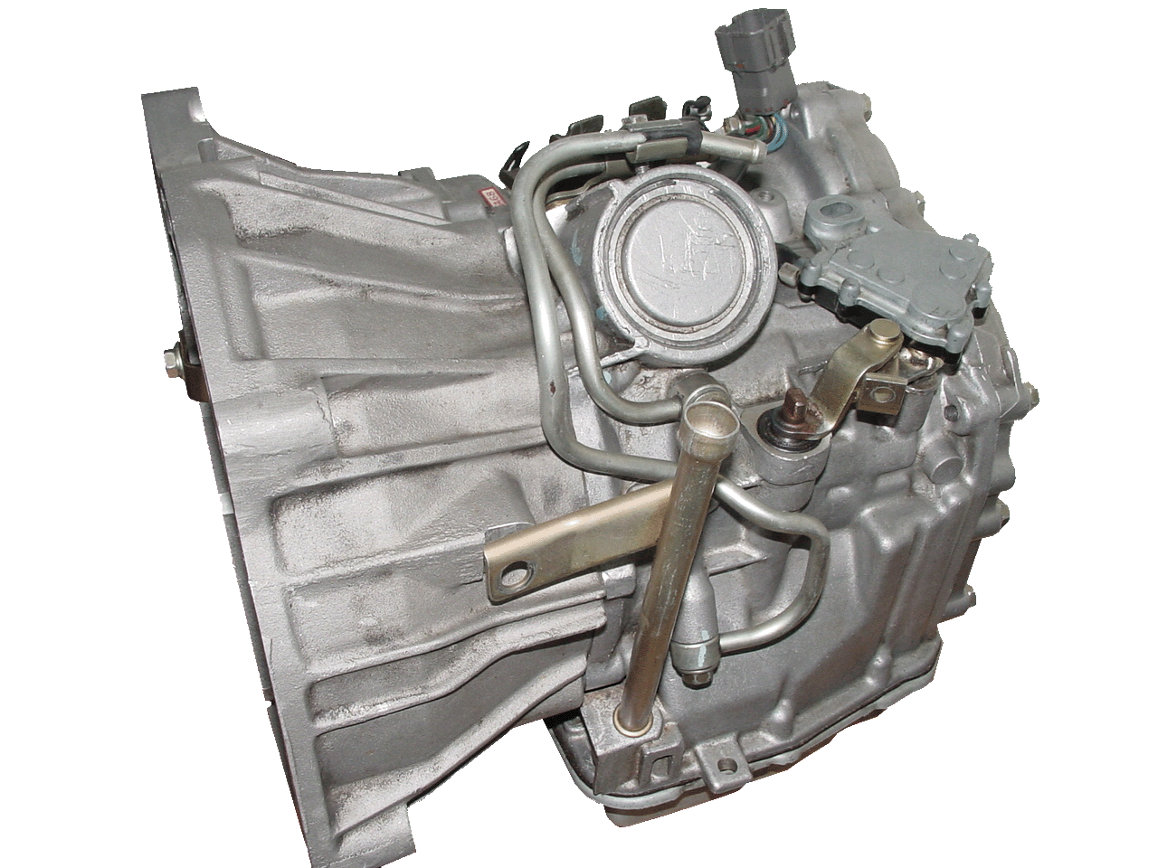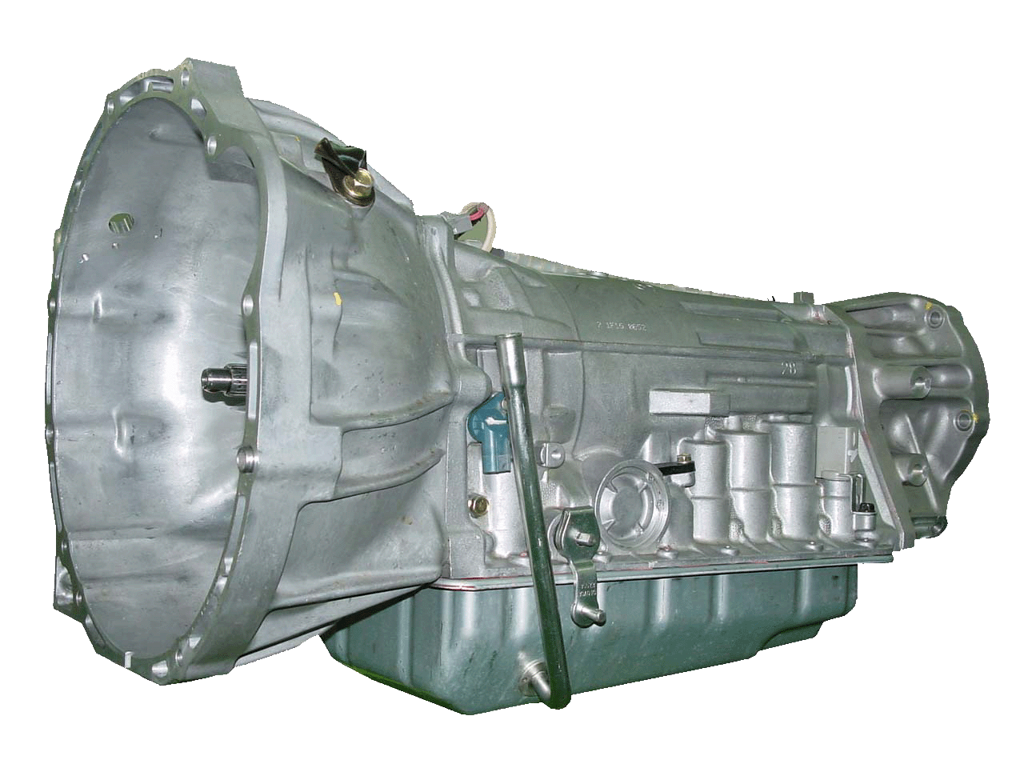
Copyright by Hyundai Motor Company. All rights reserved.
Index

Subject Page
Shiftlever operation 3
Model range and identification 5
Maintenance 7
ATF fluid requirements 9
Inspection for leakage 10
Inhibitor switch 11
General operation and precautions 13

Shift lever operation
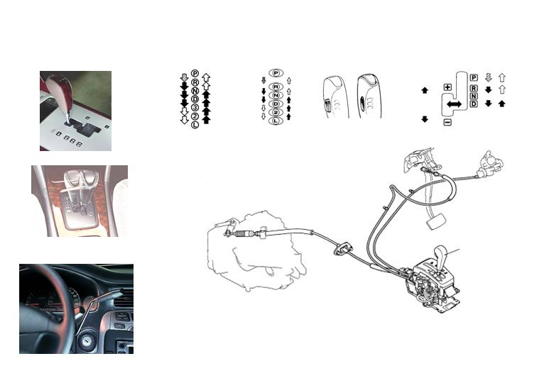
To prevent unsafe operation the selector lever can not be moved to certain position unless a specific operation is made. For example a button has to be pushed or a side movement has to be made first before the lever can be moved in the longitudinal direction (step gate type). The shift lever can be installed on the floor or at the steering column. As can be seen in the pictures, recently some models have a so called sports mode. This vehicles can be driven in the conventional automatic mode (D), but if the lever is moved into manual gate, gears can be selected manually similar to a manual transmission. Note that the control unit prohibits unreasonable operation. Some models are equipped with a shift interlock mechanism. In that case the selector lever can only moved out of P- Position if the Key is inserted and not in “Lock” position and the brake pedal is depressed. Note: In order to get the key out the shift lever must be in P position. Note that the interlock can be also controlled electrically instead of cables.
Operation of a vehicle with AT: depending on the model different select patterns are available: 4 step plus sports mode, 7 step, or models with overdrive switch.

P-position is used for parking, the output shaft is locked mechanically. The vehicle cannot be moved. Starting is possible.
R-position is used to reverse the car. No starting possible. The back up lamps are switched on.
N-position is used if the vehicle is stationery and the creeping of the car should be avoided with out depressing the brake pedal. Output shaft is not locked. Starting is possible
D-position is used for general driving. This is the standard position for driving on ordinary roads. Shifting is made automatically through all forward gears. No starting possible. If the brake is not depressed the car will have a tendency to move forward (creeping).
Position 3 allows automatic shifting from 1-3 gear .Some models have an overdrive switch instead of lever position 3. In this case switching off the overdrive does exactly the same function. No starting possible.
Position 2 allows shifting between 1 and 2 gear only. No starting possible.
Position L fixes the transmission into 1 gear. No starting possible.
The reasons to allow only limited automatic shifting are basically : to avoid unintended forward and backward shifting during uphill driving and to have a better engine brake performance during downhill driving. In case of a sports mode transmission there is no 3,2,L position as the gear can be selected by moving the lever into the manual gate and using + /- to fix a specific gear. Note: in previous purely mechanically controlled transmissions there was another cable to be adjusted properly to achieve proper shifting of the transmission :the kick down cable.

Model range and identification
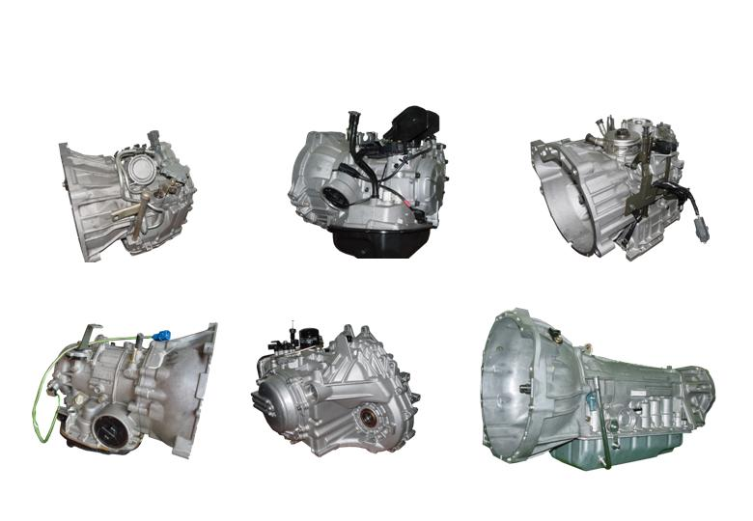
In order to cope with the specific needs for different vehicles and markets Hyundai uses several different automatic transmissions in the product range, such as :
Model: A163 is a 3-speed electronic controlled front wheel driven automatic transaxle produced by AISIN, Japan and there are two divisions as follows.A163-A is for 0.8ε Engine (DOM only) A163-B is for 1.0ε Engine, application: MX (Atos, Visto, Atos Prime)
The A4AF3 model is the latest development among the alpha automatic transaxles (advanced alpha A/T). It is a 4-speed electronic controlled front wheel driven transaxle produced by HMC. Application: X -3 ,LC (Accent), TB (Getz), LD,C-car The vehicles equipped an alpha engine)
Model: F4A series and F5A series
The F4A51 model is a HIVEC 4-speed electronic controlled front wheel driven automatic transaxle produced by HMC and installed on the vehicle that has the engine volume of 2.0L or more. The F5A51 model is a 5-speed electronic controlled front wheel driven automatic transaxle produced by HMC and is based on the 4 speed version. Depending on the actual vehicle there are several versions available, such as the A5HF1 for the NF Sonata. Also for the 4 speed transmissions several versions are available.
Model: AW30-40LE is a 4-speed electronic controlled rear wheel driven automatic transmission produced by AISIN, Japan. Application: HP (Terracan)

Model: FRA is a 4-speed electronic controlled front wheel driven automatic transaxle produced by JATCO, Japan. Application: MX(Atos, Visto, Atos Prime)
Model: KM175 is a Kyoto Model 4-speed electronic controlled front wheel driven automatic transaxle produced by HMC and there are two divisions as follows. KM175-5 is for 2.0SOHC KM175-6 is for 2.0DOHC Engine Application: Y-3(Sonata), Santamo
Model: W4A51 is a 4-speed electronic controlled front wheel driven automatic transaxle produced by HMC and 4-wheel drive mechanism were added on the F4A51 HIVEC 4-speed A/T. Application: Santa fe
Model: F5AH1 is a kind of 5-speed HIVEC electronic controlled front wheel driven automatic transaxle produced by HMC, and this is most big one among HIVEC 5-speed A/T. Application: LZ (Centennial), TG
The identification number is stamped as a row of with 6 sections as indicated below.
1st Digit : T/M model M : F4A42-1, N : F4A42-2, P : F5A51-2
2nd Digit : Product year W : 1998 X : 1999 Y : 2000
3rd Digit : Final gear ratio N : 4.042, K : 3.333, M : 3.770
4th Digit : Classification of detail AD : XG-CAR, BD : EF-CAR
5th Digit : Spare
6th Digits : Serial Number 000001∼999999

Maintenance
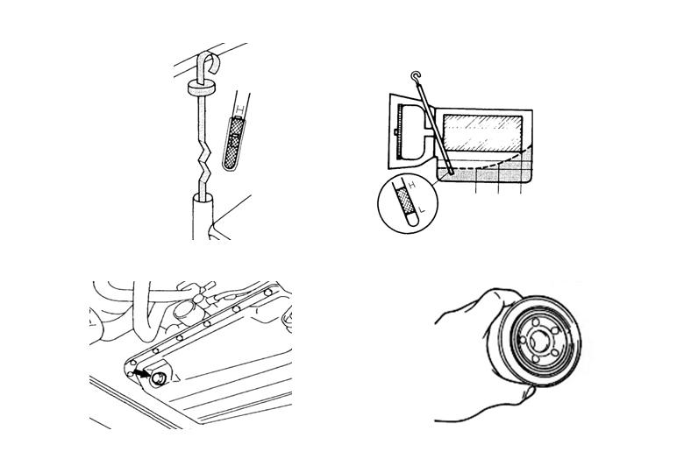
If the level is low, the oil pump will draw in air along with the fluid, which will cause bubbles to from inside the hydraulic circuit. This will in turn cause the hydraulic pressure to drop, which will result in late shifting and slipping of the clutches and brakes. If there is too much ATF, the gears can churn it up into foam and cause the same conditions that can occur with low fluid levels. In either case, air bubbles can cause overheating and oxidation of the fluid which can interfere with normal valve, clutch, and brake operation. Foaming can also result in fluid escaping from the transmission vent, in which case it may be mistaken for a leak.

How to check the fluid level properly:
1. Run the engine until the fluid temperature rises to operation temperature (70-80°C)
2. Park the vehicle on a flat surface.
3. Move the selector lever through all positions to fill the torque converter and the hydraulic circuits with ATF. And put the select lever on “N” position.
4. Check the oil level and condition with level gauge after wiping off any dirt around the oil level gauge. If the fluid smells burned, it means that the fluid has been contaminated be fine particles from the bushes and friction materials; a transmission overhaul and flushing may be necessary.
5. Check the ATF level is on “HOT” mark on the gauge. If level is lower than this, replenish the ATF up to “HOT” mark.
6. Securely insert the oil level gauge.
7. The fluid and the oil filter should always be replaced when overhauling the transmission or after the vehicles have been driven under severe conditions. In addition to the main oil filter inside of A/T, a sub oil filter has been adopted on some transmissions ( Hivec), to filter the fine impurities not filtered at the main oil filter at all times. Pay attention :these oil filters are special filters that are only to be used for the automatic transmission The sub oil filter and the engine oil filter look similar. They can be distinguished by the identification mark, “A/T only” at the upper side of the AT sub oil filter. Before installing the new sub oil filter, apply a small amount of automatic transmission fluid to the O-ring . When tightening the drain plug make sure to use a new gasket and the correct tightening torque. If you have to ad ATF fluid or if you have to replace it make sure that you use the correct fluid, as the use of wrong fluid may lead to shift problems or damage the transmission
ATF fluid requirements
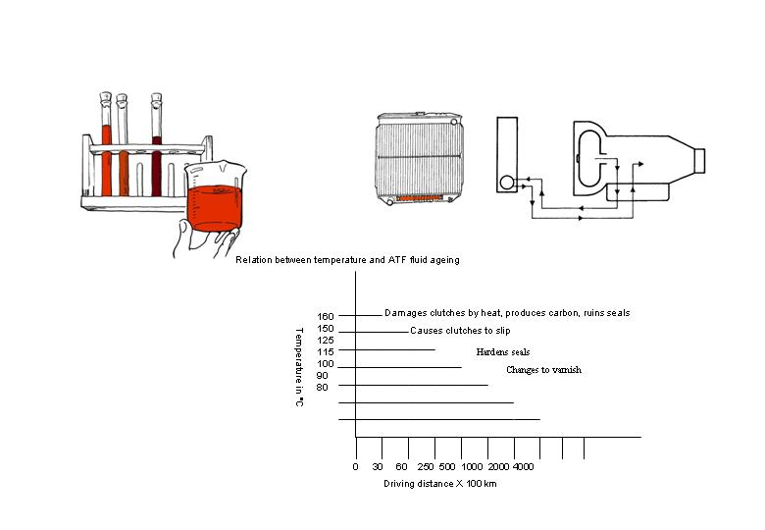
As the automatic transmission fluid pays an important role for the proper function of the transmission it is important to keep it in good condition. Therefore it is mandatory to follow the periodic maintenance schedule precisely. The maintenance includes not only fluid level check, but also the replacement of the fluid in specific intervals. depends on model and market). When replacing the fluid follow the given procedures from the workshop manual precisely and take special care to use the correct fluid, as different types are available. Using the wrong fluid can cause not only poor shift quality, but lead to a complete transmission break down. New, ATF (Automatic Transaxle Fluid) should be red, because red dye is added to distinguish it from engine oil or antifreeze. As the vehicle is driven, the transaxle fluid will begin to look darker. The color may eventually appear light brown. Also, the dye, which is not an indicator of fluid quality, is not permanent. Therefore, do not use fluid color as a criterion for replacing the transaxle fluid. However, further investigation of the automatic transaxle is required if the fluid is dark brown or black, if it smells burnt or particles can be seen or felt on the dipstick. Again: Be aware to use the correct fluid !! As the wrong one may cause problems such as shift shocks, judder or even damage to the transmission proper.

Inspection for leakage
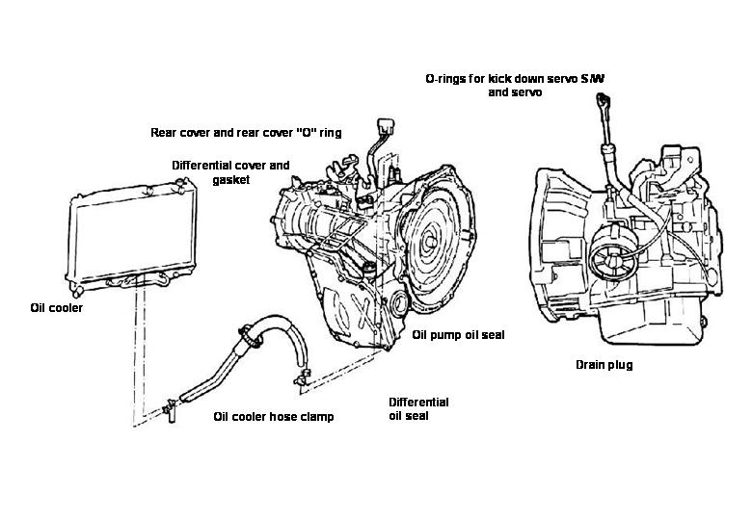
If transmission fluid has to be added, do not only replenish, but check for leakage as well. In the given sample you can see the major possibilities for leakage to occur. Please note that overfilling may cause oil to be pushed out from the breather or the dip stick. Therefore make sure to detect the correct cause for oil coming out from the transmission.

Inhibitor switch
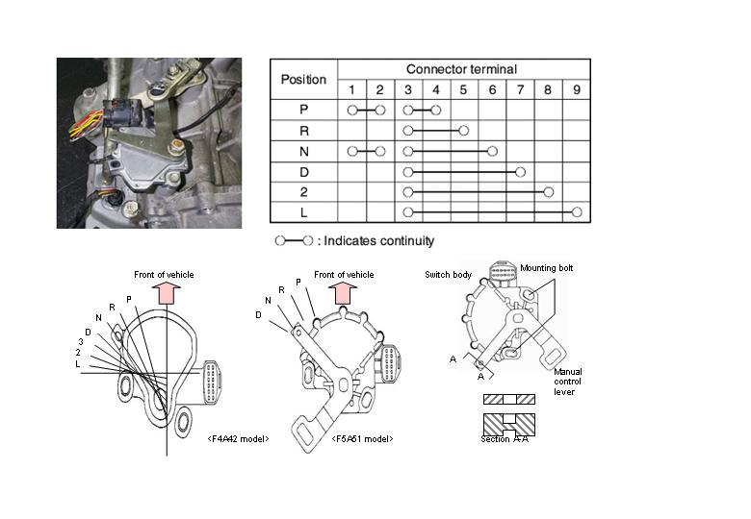
In a mechanical controlled transmission the inhibitor switch is a pure start safety mechanism. When the selector lever is not in position “P” or “N”, the electrical circuit for starting the engine is in the OFF state. Therefore, the engine does not start in this condition, even if the ignition switch is turned to the “START” position. The inhibitor switch is installed on the transaxle case and connected with the manual control shaft. The inhibitor switch includes also internal circuits for the detection of the selector lever position this signals are used for the indication of the selected gear in the instrument cluster. In case of electronic controlled transmissions, as for example the Hivec series, the signals of the shift position are used by the electronic control unit for the selection of the proper shift range. The correct electrical function of the switch can be checked by multimeter, measuring the continuity between the related terminals. The picture above shows a sample only, as different versions are existing. To see the individual layout, please refer to the Workshop manual. In case of any discrepancy, check if the switch is installed and adjusted in the correct position. If the adjustment is o.k., replace the switch. In that case make sure to use the correct one, as different versions are available.

Inhibitor switch and control cable adjustment:
1. Set the selector lever to the “N” position.
2. Loosen the control lever coupling nut so that the control cable and lever are free.
3. Set the manual control lever to the neutral position.
4. Loosen the inhibitor switch mounting bolts and turn the inhibitor switch body so that the hole in the end of the manual control lever and the hole (cross section A-A in the figure) in the flange of the transaxle range switch body flange are aligned.
5. Tighten the transaxle range switch body mounting bolts to the specified torque. Be careful at this time that the position of the switch body is not changed.
6. Gently pull the transmission control cable in the direction of front side of vehicle in order to eliminate to much free play, and then tighten the adjusting nut.
7. Re-check that the selector lever is in the “N” position.
8. Check that each range on the transmission side operates and functions correctly for each position of the selector lever.

General operation and precautions
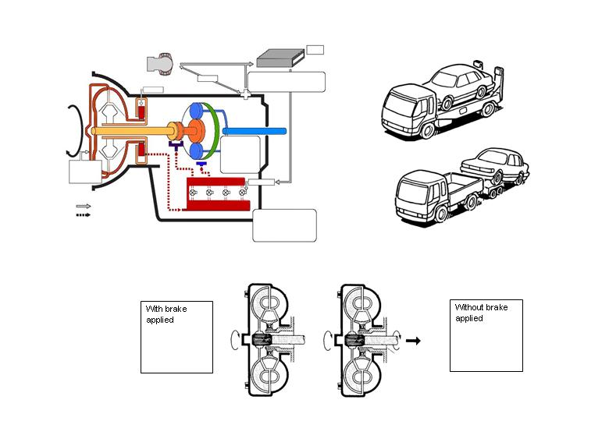
This picture shows the basic outline of an modern automatic transmission
In former times an automatic transmission was controlled by the hydraulic system only and had two main sections: hydraulic and the mechanical. Nowadays an automatic transmission consists of 3 main sections: Mechanical section, hydraulic section and electric or electronic section. The function of each part of the transmission is as follows:
Torque converter: transmits the engine torque to the transmission by automatic transmission fluid
Oil pump: pressurizes the automatic transmission fluid
Hydraulic control system: regulates the pressure and directs the fluid to the clutches and brakes
Electronic control system: collects the data by the means of sensors. Based on this input the control unit drives the actuators (solenoids) in order to control the gear shifting.
The torque converter transmits the torque to the transmission and drives the oil pump. The pump creates pressure, which is applied to the hydraulic control system. The sensors detect the operating conditions and send this information to the control unit. Using this input and the internal map the control unit determines necessary gearshifts and activates the solenoids accordingly. The hydraulic pressure is then routed to the clutches and brakes in accordance with the activated solenoids. Depending on the activated clutch or brake different parts of the gear train are connected or held stationary in order to achieve the necessary gear shift. Note: in early transmissions the control was made without electronic control. Gear shifting was made only by the hydraulic control system using mechanical valves reacting on pressure changes related to speed (governor) and throttle position (throttle cable).
Creeping phenomenon
The engine power is transmitted from the engine to the transmission via the automatic transmission fluid (inside of the torque converter). Even in the transmitted torque is strong enough to move the vehicle if no brake is applied. Therefore it is necessary to select N, if the driver does not want to depress the brake during the stop.
Towing automatic transmission vehicles. In the case you have to tow a car with automatic transmission, the towing distance and the towing speed must be limited. As a rule of thumb: maximum towing distance is 50 km and maximum towing speed is 50km/h. For exact figures, please refer to the owners manual of the specific vehicle. As the oil pump is not operated during towing, these limits are important to prevent seizure of the internal parts of the transmission. If you have to tow the vehicle for a longer distance or faster than 50 km/h or if the vehicle has an internal transmission fault special measures must be taken. For example lifting the vehicles driven wheels or best : using a flat bed truck.

